COMMUNITY EMPOWERMENT (SCOTLAND) ACT 2015

ASSET TRANSFER REQUEST FORM

IMPORTANT NOTES:
This is a standard asset transfer request form which can be used to make a request to any relevant authority. Relevant authorities may also provide their own forms in their own style.
You do not need to use this form or a relevant authority’s form to make an asset transfer request, but using a form will help you to make sure you include all the required information.
You should read the asset transfer guidance provided by the Scottish Government before making a request. Relevant authorities may also provide additional guidance on their schemes.
You are strongly advised to contact the relevant authority and discuss your proposals with them before making an asset transfer request.
When completed, this form must be sent to the relevant authority which owns or leases the land your request relates to.

This is an asset transfer request made under Part 5 of the Community Empowerment (Scotland) Act 2015.

Information about the community transfer body (CTB) making the request
  - Name of the CTB making the asset transfer request
Brightons Village Community Hall SCIO SC053049
  - CTB address. This should be the registered address, if you have one.
Postal address:
Main Street
Brightons
Falkirk
Postcode:
FK2 0JT
  - Contact details. Please provide the name and contact address to which correspondence in relation to this asset transfer request should be sent.
Contact name:
[REDACTED]
Postal address:
Brightons Community Hall
Main Street
Brightons
Falkirk
Postcode:
FK2 0JT
Email:
brightonsvillagehall@outlook.com
Telephone:
☐ We agree that correspondence in relation to this asset transfer request may be sent by email to the email address given above.
You can ask the relevant authority to stop sending correspondence by email, or change the email address, by telling them at any time, as long as 5 working days’ notice is given.
  - Please mark an “X” in the relevant box to confirm the type of CTB and its official number, if it has one.
 | Company, and its company number is ………….
 | Scottish Charitable Incorporated Organisation (SCIO), and its charity number is SC053049 | X
 | Community Benefit Society (BenCom), and its registered number is ………………………………
 | Unincorporated organisation (no number)

Please attach a copy of the CTB’s constitution, articles of association or registered rules.
  - Has the organisation been individually designated as a community transfer body by the Scottish Ministers?
No ☐
Yes ☐
Please give the title and date of the designation order:

  - Does the organisation fall within a class of bodies which has been designated as community transfer bodies by the Scottish Ministers?
No ☐
Yes ☐
If yes, what class of bodies does it fall within?
Section 80(1)(b) ‘it is a Scottish charitable incorporated organisation the constitution of which includes provision that the organisation must have not fewer than 20 members’.

Information about the land and rights requested
  - Please identify the land to which this asset transfer request relates.
You should provide a street address or grid reference and any name by which the land or building is known. If you have identified the land on the relevant authority’s register of land, please enter the details listed there.
It may be helpful to provide one or more maps or drawings to show the boundaries of the land requested. If you are requesting part of a piece of land, you must give a full description of the boundaries of the area to which your request relates. If you are requesting part of a building, please make clear what area you require. A drawing may be helpful.
Brightons Community Hall
Main Street
Brightons
Falkirk
FK2 0JT
Grid Reference – NS 92892 77786
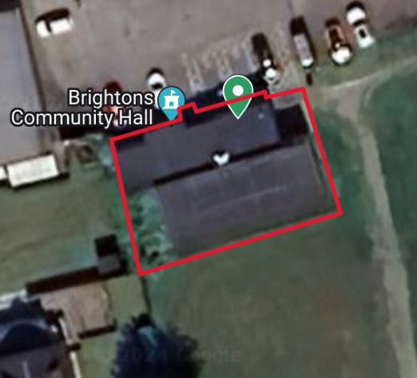
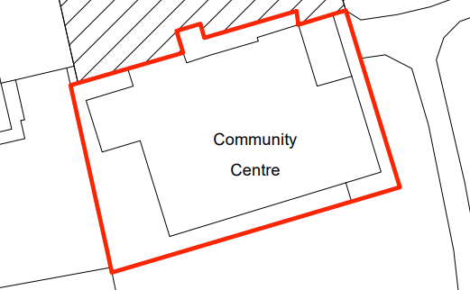
All and whole the building known as Brightons Community Hall, Falkirk, and the lands as shown above, and bounded as outlined in red.

  - Please provide the UPRN (Unique Property Reference Number), if known.
If the property has a UPRN you will find it in the relevant authority’s register of land.
UPRN: 136039852

Type of request, payment and conditions
  - Please tick what type of request is being made:

for ownership (under section 79(2)(a)) - go to section 3A
X
for lease (under section 79(2)(b)(i)) – go to section 3B
for other rights (section 79(2)(b)(ii)) – go to section 3C

3A – Request for ownership
What price are you prepared to pay for the land requested? :
Proposed price: £
Please attach a note setting out any other terms and conditions you wish to apply to the request.

3B – request for lease
What is the length of lease you are requesting?
20 Year Lease
How much rent are you prepared to pay? Please make clear whether this is per year or per month.
Proposed rent: £ 1 per annum
Please attach a note setting out any other terms and conditions you wish to be included in the lease, or to apply to the request in any other way.

3C – request for other rights
What are the rights you are requesting?

Do you propose to make any payment for these rights?
Yes ☐
No ☐
If yes, how much are you prepared to pay? Please make clear what period this would cover, for example per week, per month, per day?
Proposed payment: £ per
Please attach a note setting out any other terms and conditions you wish to apply to the request.

Community Proposal
  - Please set out the reasons for making the request and how the land or building will be used.
This should explain the objectives of your project, why there is a need for it, any development or changes you plan to make to the land or building, and any activities that will take place there.

Brightons is well catered for a village of its size. Main Street and Station Road include a pharmacy, a café, a Chinese takeaway, two grocers, a hairdresser and a tanning shop. Lawrie Park is a recreational area which has one football pitch which is home to Brightons F.C. Brightons Community Hall is located next to Brightons Parish Church on Main Street.
The group formed in 1960’s and is currently known at Brightons Village Community Hall SCIO SCO53049, which formed on the 9th of January 2024. Prior to this, the Group was known as the Brightons Village Hall Management Committee, who were responsible for the management of the building, and the lets. The group have been working together to form a plan of action, in support of retaining the community building through a Community Asset Transfer lease agreement with Falkirk Council.
The Group’s charitable purpose is for the provision of recreational facilities, or the organisation of recreational activities, with the object of improving the conditions of life for the persons for whom the facilities or activities are primarily intended.
With the announcement of Falkirk Council’s Strategic Property Review, and in line with the recommendations of the review, the Brightons Village Hall will be closed if it does not transfer to community control. The Community Asset Transfer will prevent the closure of this building, and preserve it for community use for future generations.
The organisation’s commitment to improvement is further evidenced by our recent successful application for National Lottery funding, which will be allocated towards modernising the existing restroom facilities. Moreover, in collaboration with Falkirk Council, an agreement has been reached to proceed with the replacement of the front door, signifying a significant upgrade to the hall’s infrastructure. These developments collectively signal a new chapter for Brightons Community Hall, one that promises enhanced functionality and continued service to the community.
Our future aims are:
Have an income that is sustainable
Have a range of income sources to cover the costs of running the building, maintenance, such as grants, donations, hiring out space, delivering contracts and seeking sponsorship
Make use of good ideas and resources within the community and can adapt to changing circumstances
Be a collaborative effort, where many people in the community are involved
Provide a means for alternative approaches to service delivery underpinned by the principles of community involvement and partnership
Facilitate a place where different local partners in a neighbourhood can come together and address the issues that matter most to them.

Benefits of the proposal
  - Please set out the benefits that you consider will arise if the request is agreed to.
This section should explain how the project will benefit your community, and others. Please refer to the guidance on how the relevant authority will consider the benefits of a request.
The hall operating in community ownership will improve the sense of community with many groups attracting people to come from a wider area and will be able to pass on information to others. The members of the hall propose to look at holding a variety of activities which will encourage different age groups to mix both socially and in specific classes.
The local Nursery holds their end of year shows and parties in the hall where there is lots of space for neighbours and residents are invited.
The Sunday School holds classes in the hall as well as using the hall for overspill for church functions.
The local primary school pupils attend various classes in the hall. For example, dancing, exercise, drama, etc.
The charity trustees will continue to work with the Church, the local Primary School and Nursery, the Friends of Quarry Park committee, the Brightons Community Council, Brightons’ Ladies Group, and any other groups who are interested. The charity trustees will hold regular meetings with all of these groups and communicate with them to ensure our community is well integrated.
We also meet regularly with our local police officers who let us know if there are any issues in the village. If any areas are identified, we will look at other classes that would help with this situation.
The group will carry out all its activities with the Falkirk Plan 2021 – 2030, at the forefront of our minds when our strategic priorities are agreed upon, wherever practicable, with reference to page 21, ‘outcome 12: fewer people struggle with feeling socially isolated or lonely.’
We currently have lets from local community groups such as Brightons Community Ladies’ Group, baby and toddler groups, Polmont Guides, paracise and yoga classes.
We work with the community, for the community. We will continue to develop partnerships with local organisations, service providers and community groups.
Our vision is to provide a community led space that helps deliver long-term, social, economic, sustainable and environmental benefits to the local community.

Our values are based on:
Working in an inclusive and respectful manner, not discriminating against anyone
Being a not-for-profit organisation and investing any surplus in the advancement of facilities for the local community
Being community led
Intergenerational approach to serving all age ranges in the community

Our objectives are:
To improve health and wellbeing of the local community
Provide increased social benefits
Empower our community and families
Community Benefit |  |  | Year 1 Benefit | Year 2-3 Benefit | Year 4-5 Benefit
Social Impact | Mental Health is improved due to increased social interaction, the reduction of social isolation, and more wealth is retained within the local community. |  | £15,000 | £32,000 | £33,000
Health Benefit | Fitness Classes.  People in the local area have an increased level of fitness, resulting in less interactions with the NHS |  | £24,000 | £49,225 | £50,000
 | Total |  | £39,000 | £81,225 | £83,000

Restrictions on use of the land
  - If there are any restrictions on the use or development of the land, please explain how your project will comply with these.
Restrictions might include, amongst others, environmental designations such as a Site of Special Scientific Interest (SSI), heritage designations such as listed building status, controls on contaminated land or planning restrictions.
There are no known restrictions on the use or development of the land.

Negative consequences
  - What negative consequences (if any) may occur if your request is agreed to? How would you propose to minimise these?
You should consider any potential negative consequences for the local economy, environment, or any group of people, and explain how you could reduce these.

We have considered potential negative consequences of the group taking over the building through Community Asset Transfer as:
Costly repair work is required for the building we will need to fund
Utility costs are high for the building and we understand the risk of these increasing
There is a risk of us not being able to attract enough business to ensure the hall is able to continue
We understand there is a lot of volunteering work required for our proposal to work and are reliant on there being a continued involvement from the community to help with this
Capacity to deliver
  - Please show how your organisation will be able to manage the project and achieve your objectives.
This could include the skills and experience of members of the organisation, any track record of previous projects, whether you intend to use professional advisers, etc.
The group formed in 1960’s and is currently known as Brightons Village Community Hall SCIO SCO53049, which formed on the 9th of January 2024. Prior to this, the Group was known as the Brightons Village Hall Management Committee, who were responsible for the management of the building, and the lets. The group have been working together to form a plan of action, in support of retaining the community building through a Community Asset Transfer lease agreement with Falkirk Council.
The board of trustees at Brightons Village Community Hall comprises a diverse group of individuals, each bringing a unique set of skills and experiences to the table. Several of our trustees have served on the management board of the hall for many years, bringing a wealth of experience, and strong relationships with the users of the hall and the wider community. Many trustees have also volunteered extensively with various other charities over the years. Our commitment to our community extends beyond our village hall. Several trustees on our board work directly with children, adults, and nursing services. Additionally, they serve as handy individuals, performing small tasks that enhance the hall’s functionality.
The board have a varied skill mix with a rich blend of skills and experiences, that includes full-time professionals and retired individuals. Our backgrounds span different industries, ensuring a well-rounded perspective in decision-making. Comfortable in public settings, the board actively participates in meetings and engages with the community. We communicate effectively, whether addressing large audiences, or having those one-on-one conversations. The board champion causes that benefit the local area and our local residents. Our trustees bring project experience, enabling us to oversee initiatives efficiently. Our ability to plan, execute, and evaluate projects ensures successful outcomes. Our experience in negotiation, collaboration, and strategic planning enhances the hall’s operations. Our charity trustees handle costings and budgets adeptly. Our financial acumen ensures responsible resource allocation, where several trustees have successfully run their own profitable businesses. Our entrepreneurial insights contribute to sustainable practices and financial stability. The board maintains valuable connections with skilled professionals such as joiners, builders, and electricians – these contacts prove invaluable for maintenance and improvement projects.
Our treasurer will carry out the necessary record keeping, passing the monthly detail to our bookkeeper who will maintain our accounts and forward to our accountant to complete our annual Return to OSCR.
We will look to undertake a full survey of the building and work with the council on a list of changes that are required prior to lease agreement, the council will also provide their own survey and all details of building works planned etc. We look for a survey that will cover RAAC and Asbestos, if required.
We will continue to work with our partners in the public, private and third sector.

Level and nature of support
  - Please provide details of the level and nature of support for the request, from your community and, if relevant, from others.
This could include information on the proportion of your community who are involved with the request, how you have engaged with your community beyond the members of your organisation and what their response has been. You should also show how you have engaged with any other communities that may be affected by your proposals.
In relation to the continued promotion of our community hall, word of mouth through the local community's active engagement will remain a key component. We recognise the value and impact of social media, and we will make strong efforts to promote our services through Facebook, Twitter and Instagram. We are currently working on designing our new website. Our plans are to provide an attractive, easy to navigate site which will highlight what we have to offer. We recognise the importance of keeping this updated and creating interest through blogs and good news stories. We conduct regular advertising via posters in community facilities and local shops: we ensure that Brightons Village Hall is advertised and promoted where possible.
As part of our community engagement, we surveyed the users of our hall and our community – we gained over 100 responses, both online and in person.
Figure Below.

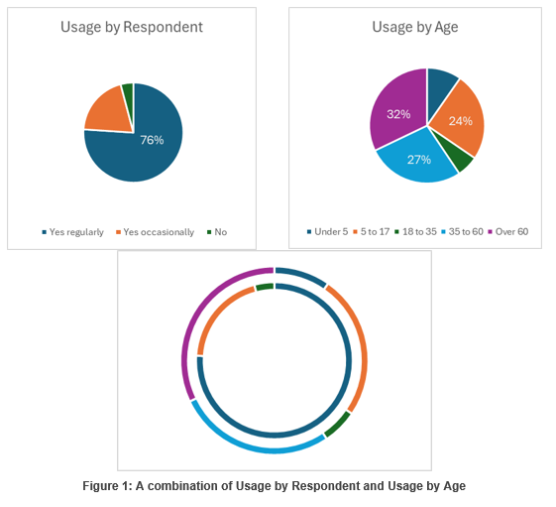
We plan to install 2 new notice boards outside the hall, we currently have one at present.
The Fun Day in Brightons, was held by Friends of Quarry Park in conjunction with Brightons Village Hall. This was to raise funds to replace the children’s play park. There was games and entertainment outside in the park, teas and coffees in the Church Hall, and face painting with various craft stalls in the hall. This also gave us the opportunity to promote the hall and the activities held there. We had notices and pictures on display of the various groups and the spaces that are available for hire. The board of trustees spoke to a large number of people on the day, where a large proportion of those left their contact details, to be notified of the progress and what part they could play in keeping the hall operational. Some people didn’t know the hall was available for hire.
We have held 2 public meetings with another 2 proposed soon, having them on afternoon and evening gave more people the opportunity to come along. We propose to hold open days where the hall users can promote their businesses in the hall.

Funding
  - Please outline how you propose to fund the price or rent you are prepared to pay for the land, and your proposed use of the land.
You should show your calculations of the costs associated with the transfer of the land or building and your future use of it, including any redevelopment, ongoing maintenance and the costs of your activities. All proposed income and investment should be identified, including volunteering and donations. If you intend to apply for grants or loans you should demonstrate that your proposals are eligible for the relevant scheme, according to the guidance available for applicants.
We plan to pay £1 per annum for the duration of the lease.
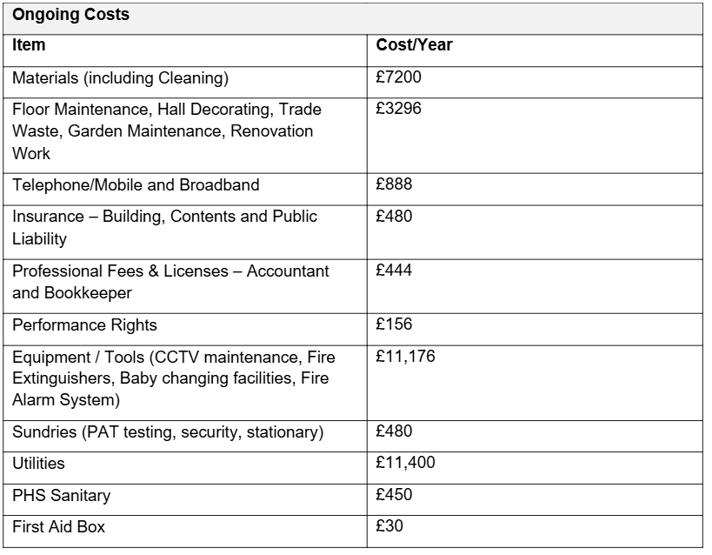
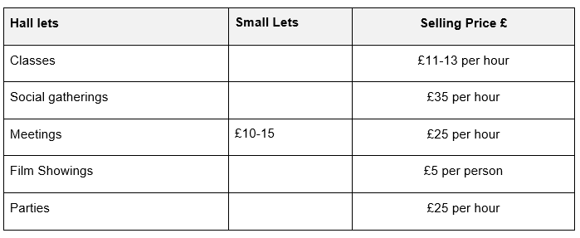
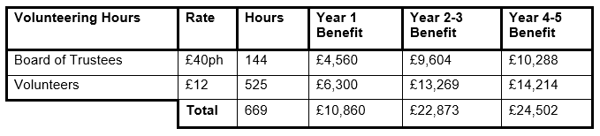
We estimate that the current usage of the hall, is about 60%. We would look to increase that to about 80% in Year 2.
We aim to refurbish the small meeting space and bring the usage of this room up to 20% by the end of Year 2. We will look to increase the usage of this space to 50% by the end of Year 3.
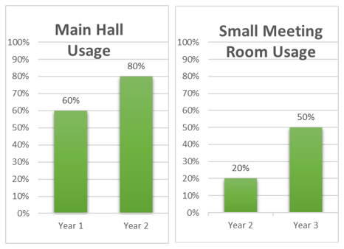
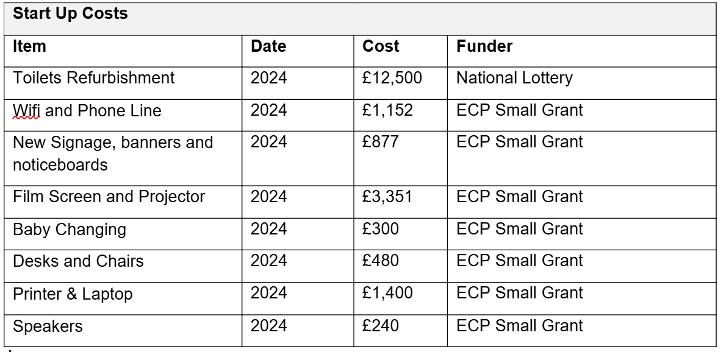
Brightons Community Hall, is a well-used, and much-loved venue in the local village. Upon entering, visitors are greeted by a small foyer that branches off into various sections of the building. The main hall is spacious, complete with a stage, and offers a picturesque view of Laurie Park’s playing fields. To one side of the foyer, lies a cozy meeting room, perfect for smaller gatherings, and on the opposite side of the foyer, is a well-equipped kitchen area. The facility also boasts universally accessible restrooms, catering to the needs of all patrons.
In a bid to better serve the community, the organisation has embarked on an ambitious project to expand the modestly sized meeting room. By repurposing the adjacent storage space and removing the connecting wall, we plan to install a new window that will not only brighten the room but will also enhance its appeal for community events and make it a much more inviting space. This strategic renovation is poised to provide a versatile venue that aligns with the diverse requirements of the community, simultaneously creating an additional source of income for our group and augmenting our capacity with two rentable spaces.
The organisation’s commitment to improvement is further evidenced by our recent successful application for National Lottery funding, which will be allocated towards modernising the existing restroom facilities. Moreover, in collaboration with Falkirk Council, an agreement has been reached to proceed with the replacement of the front door, signifying a significant upgrade to the hall’s infrastructure. These developments collectively signal a new chapter for Brightons Community Hall, one that promises enhanced functionality and continued service to the community.
Access to Falkirk Council’s Enablement Fund is requested, as illustrated in the table below.
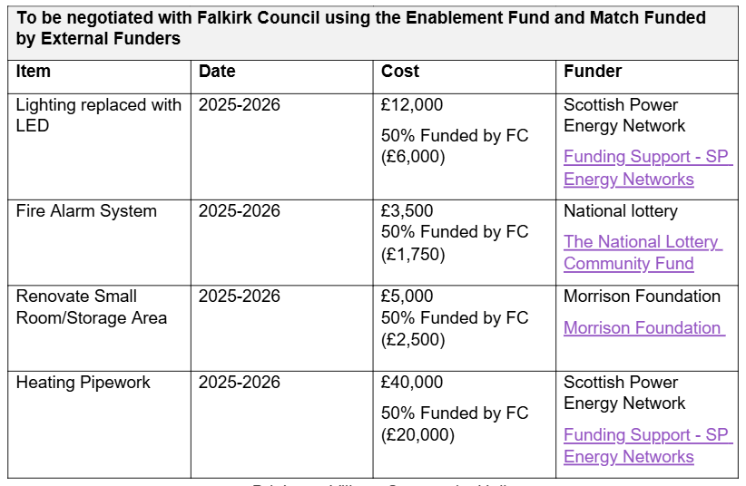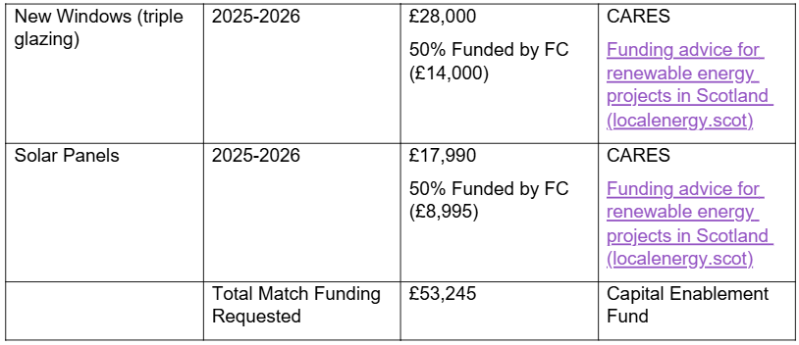

Signature
Two office-bearers (board members, charity trustees or committee members) of the community transfer body must sign the form. They must provide their full names and home addresses for the purposes of prevention and detection of fraud.
This form and supporting documents will be made available online for any interested person to read and comment on. Personal information will be redacted before the form is made available.

We, the undersigned on behalf of the community transfer body as noted at section 1, make an asset transfer request as specified in this form.
We declare that the information provided in this form and any accompanying documents is accurate to the best of our knowledge.
Name :
[REDACTED]
Address:
Brightons Community Hall, Main Street, Brightons, Falkirk, FK2 0JT

Date: 29th July 2024
Position: Secretary
Signature: [REDACTED]

Name: [REDACTED]
Address:
Brightons Community Hall, Main Street, Brightons, Falkirk, FK2 0JT

Date: 29th July 2024
Position: Trustee
Signature: [REDACTED]

Checklist of accompanying documents
To check that nothing is missed, please list any documents which you are submitting to accompany this form.
Section 1 – you must attach your organisation’s constitution, articles of association or registered rules
Title of document attached: Brightons Village Community Hall SCIO Constitution

Section 2 – any maps, drawings or description of the land requested
Documents attached: Please see all supporting documentation

Section 3 – note of any terms and conditions that are to apply to the request
Documents attached: Please see all supporting documentation

Section 4 – about your proposals, their benefits, any restrictions on the land or potential negative consequences, and your organisation’s capacity to deliver.
Documents attached: Please see all supporting documentation

Section 5 – evidence of community support
Documents attached: Please see all supporting documentation

Section 6 – funding
Documents attached: Please see all supporting documentation

